**USER MANUAL – Pik-A-Place**

**Overview:**

Pik-A-Place is an application that fetches the facebook images of a registered user and display it on an image viewer. Application allows a user to create an account and log in to the application. It uses Facebook API and user can Login to Facebook through this application and all the images in which user is tagged are fetched from user’s Facebook account and stored in Dropbox. The application uses Dropbox API and images are displayed from Dropbox to the application. The application syncs images from facebook to the user account on Pik-A-Place so that the user needs not login to facebook again and again through application.

User can also choose to get recommendation for places. For this, application uses Google Maps API and on searching a particular place, pictures of user’s facebook friends who have visited search place are populated on the image viewer. The application provides functionality for user to seek recommendations from facebook friends by using email functionality embedded in the application.

We have created a session when user logs into the application and have used AOP spring framework for the creating the session. In case of false or invalid session the application is redirected to the login page.

Following is step by step using guide for Pik- A- Place:

1.Login Page

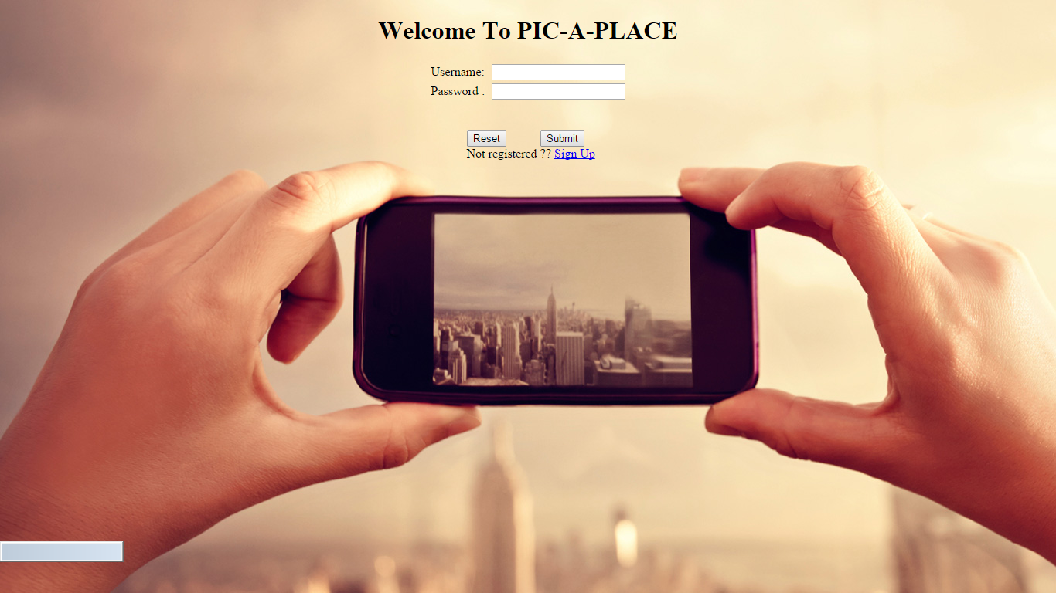

2. Sign up for a new user account.

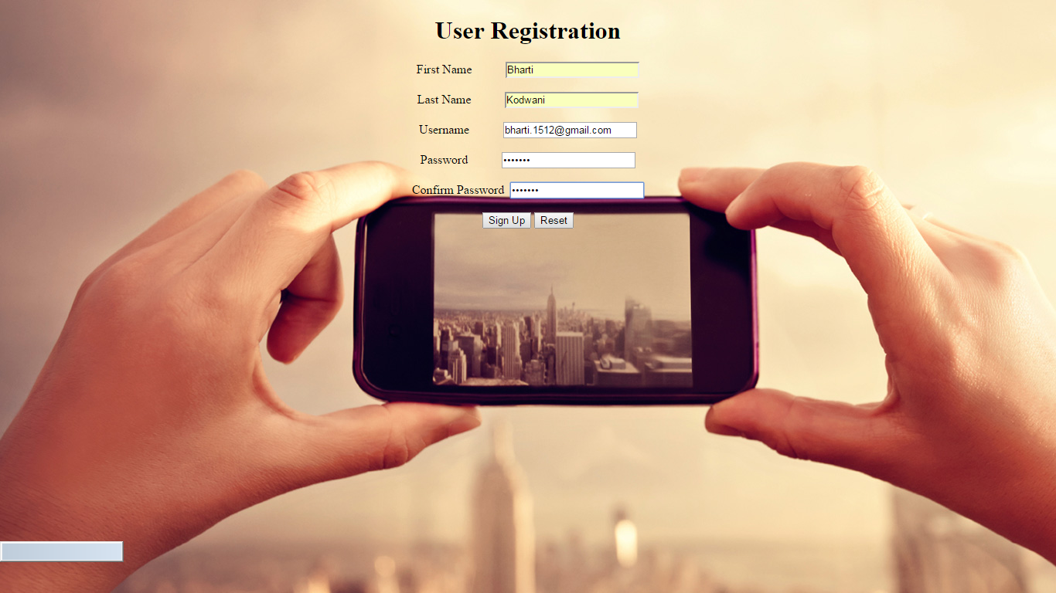

3. Successful Account Creation.

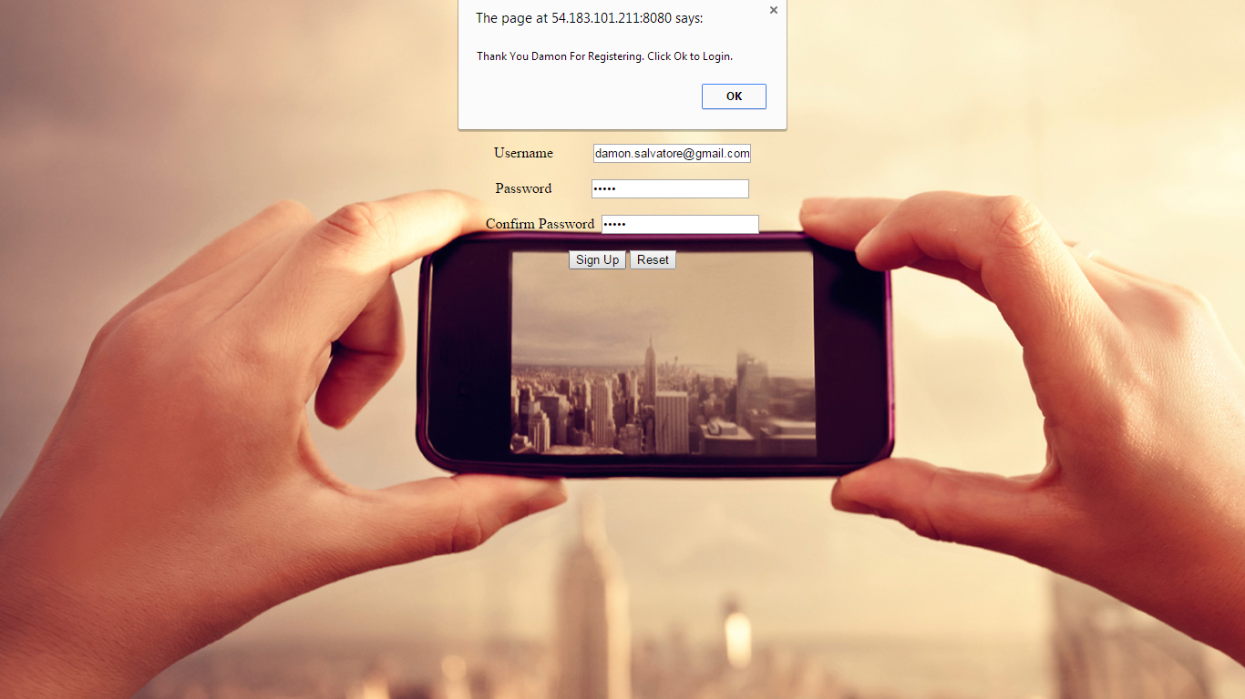

4. User logs in the system after creating an account.

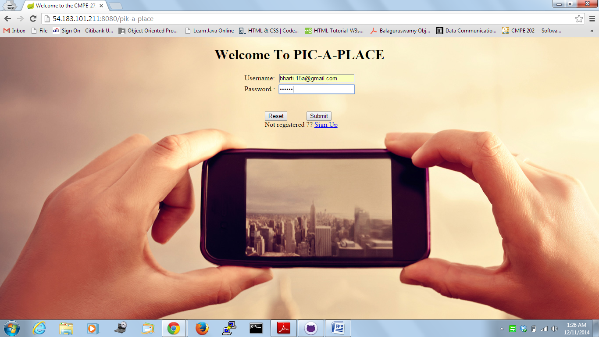

5. User logs in to the application successfully

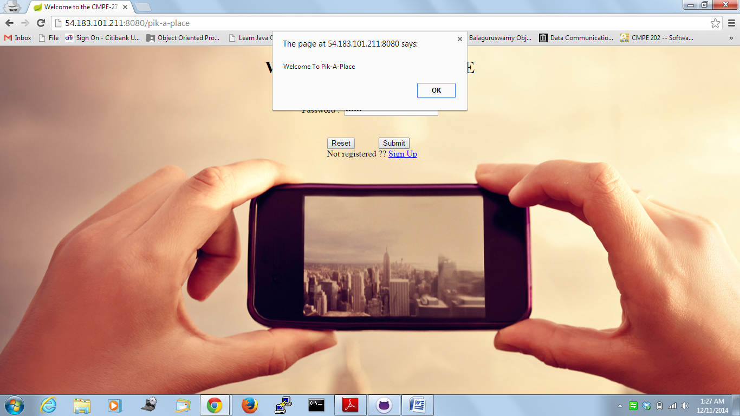

6. Home Page

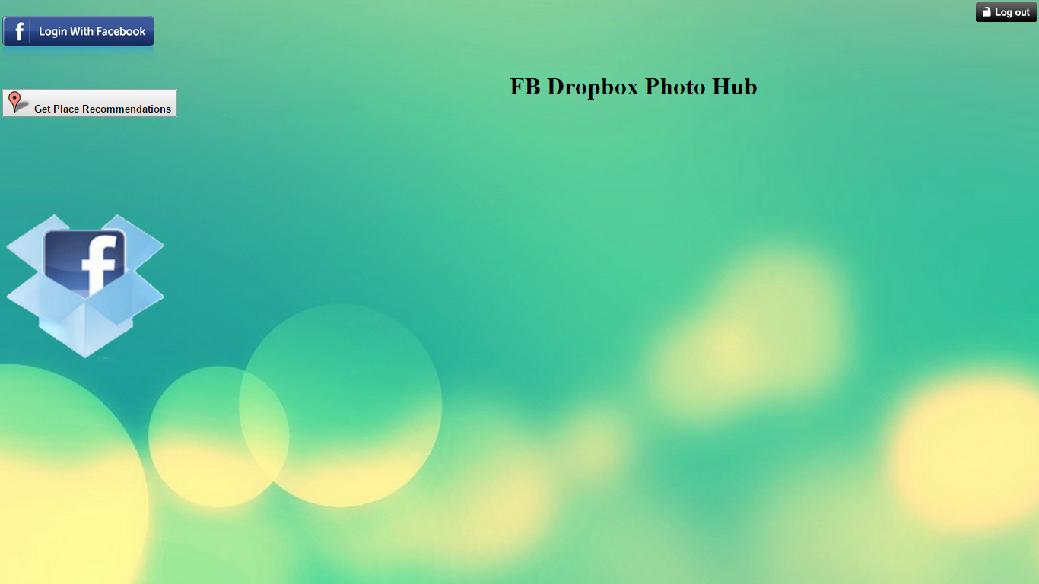

7. Login to Face book

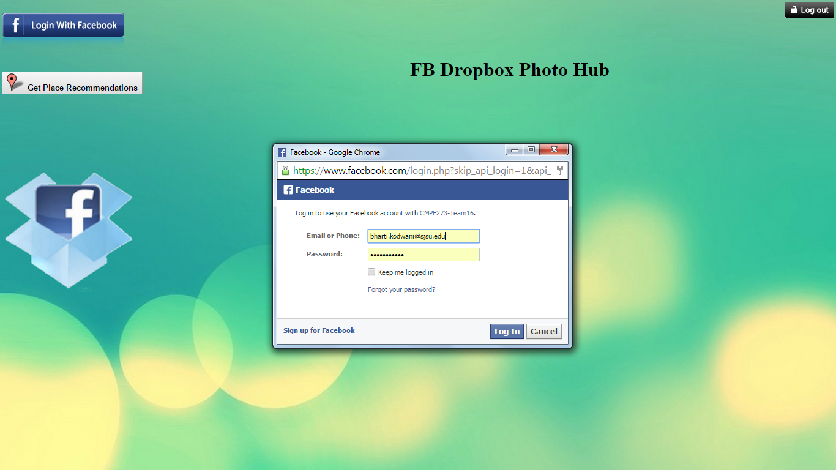

8. Face book images stored to Drop box and retrieved and posted on the viewer dynamically.

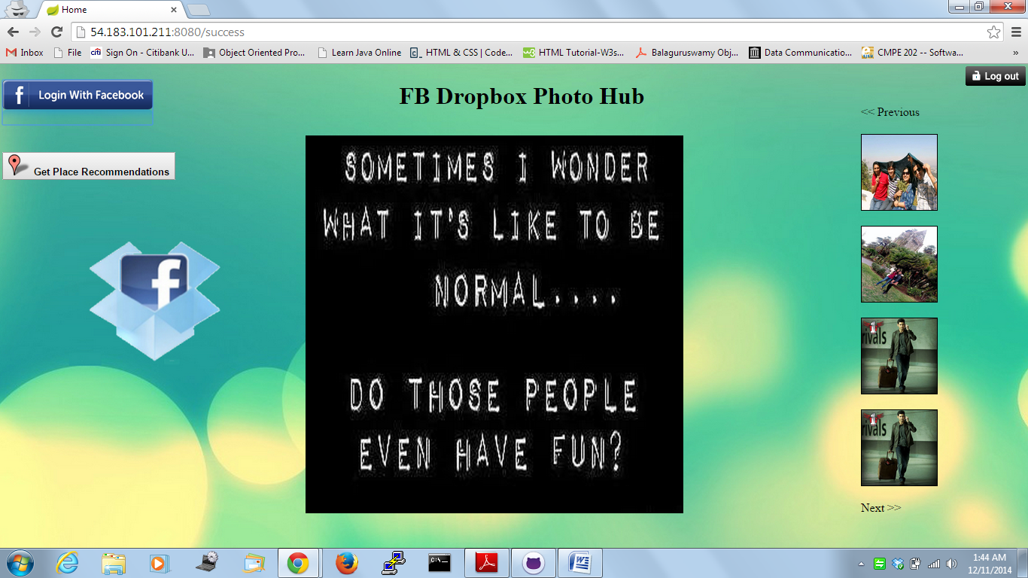

9. Recommendations page

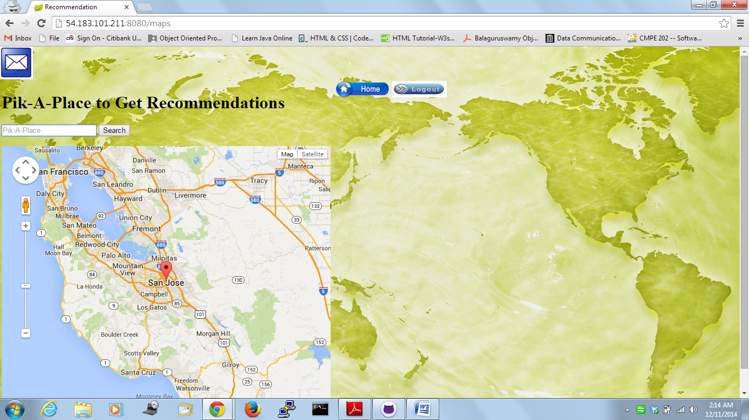

10. On searching a place, images of user’s face book friends are displayed and locations are shown with markers on Google Map. Places visited are marked on map and name and address of face book friend is shown.

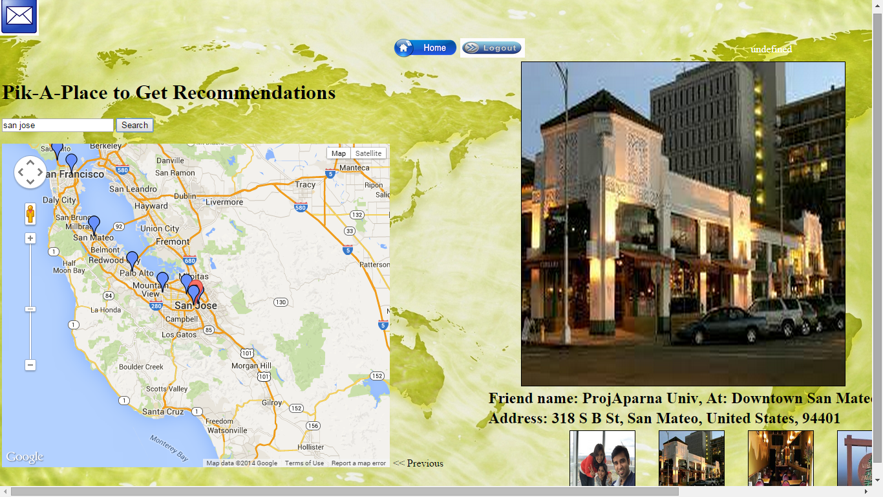

11. User can send email to his/her face book friends using email functionality provided and the mail will be triggered to the concerned friends of user.

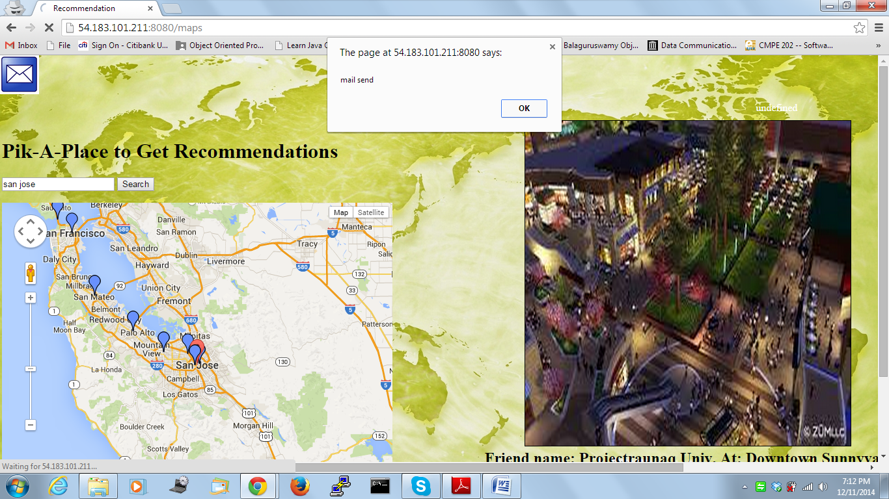

12. Mail sent from the application.

